E

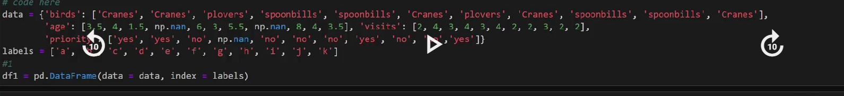



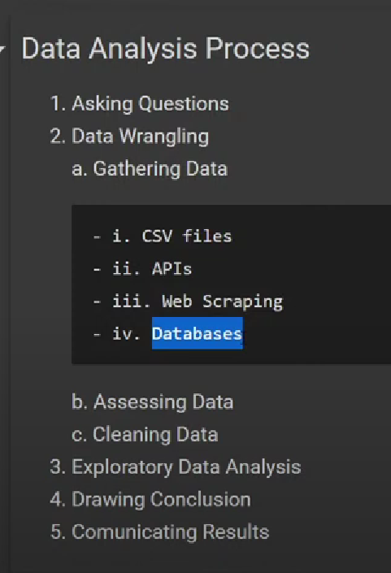

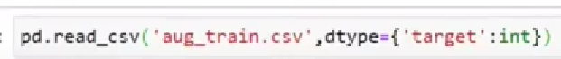

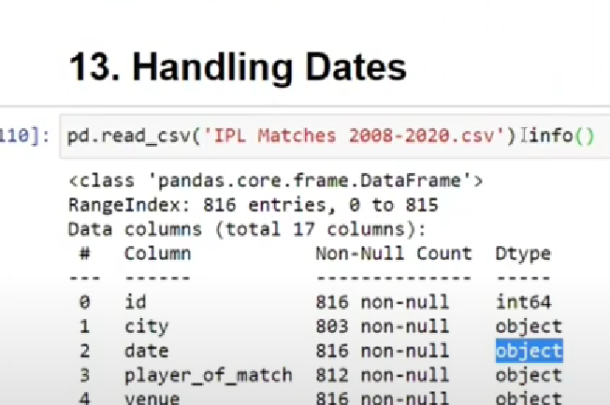

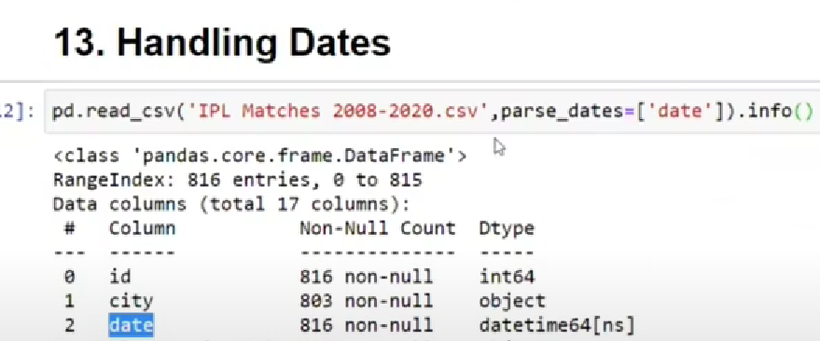

When dates are given in different different columns and u want to combine it then u can use like below🡪



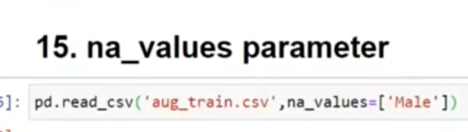



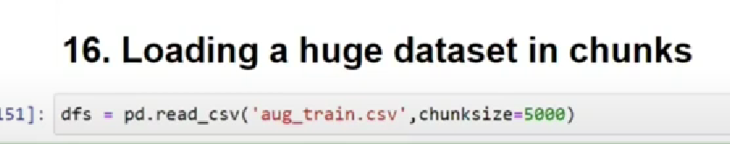

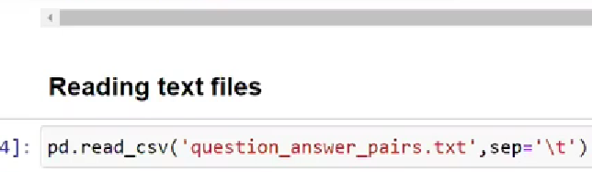

Fancy indexing 🡪list a[[1,2]] 🡪 it gives me first and second row

a[0:,[1,2]]🡪 it will give me first and second column

BOOLEAN INDEXING🡪 CONDITION BASED 1st step a>50 i.e. True or false

2ns step a[a>50] 🡪 only those numbers that are greater than 50

a9.dtype

a9.astype(np.int32)

a3.ravel() 🡪 convert any dimensiional to one dimensional array

np.dot(a3,a4)

np.ndim(a9)

np.max(y,axis=1)

np.min(y,axis=1)

sum/prod/min/max/mean/std/var

1d array loop

for i in a1:

print(i) # it will print the elements

2d array loop: gives u every row

3d array loop: every 2D array

USE THIS🡪 FOR ANY DIMENSIONAL ARRAY TO GET ITS ELEMENTS

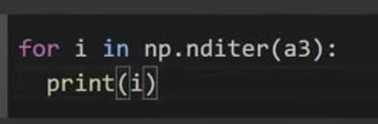

Np.random.random(())

Np.ones(())

Np.zeroes(())

Np.hstack((a4,a5))

Np.vstack((a4,a5))

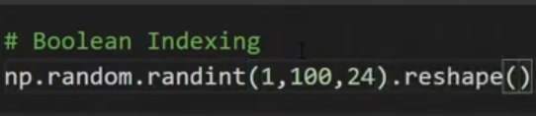 .reshape(6,4)

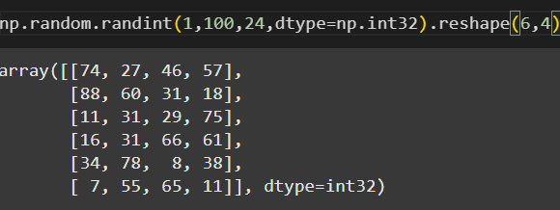

Np.identity()

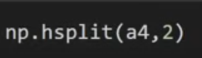 2 🡪 how many parts u want to cut it

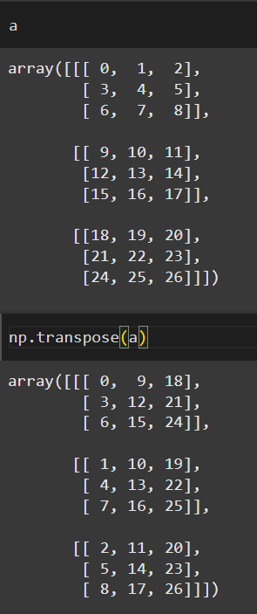

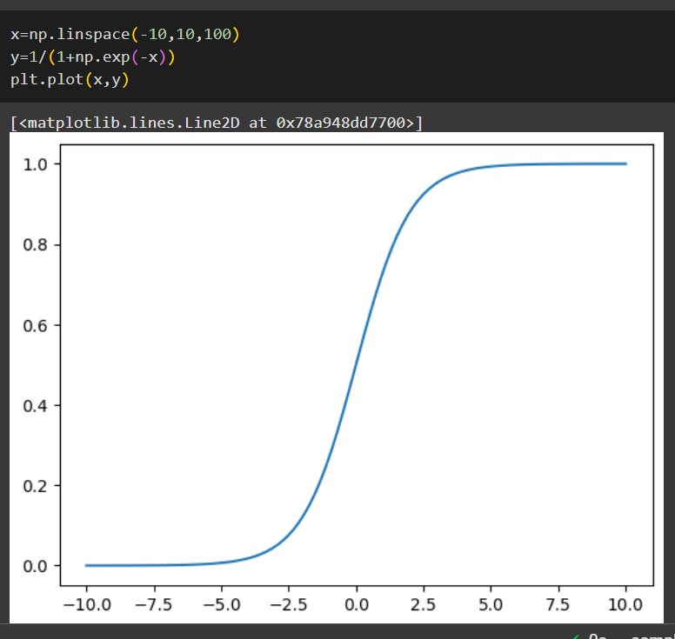

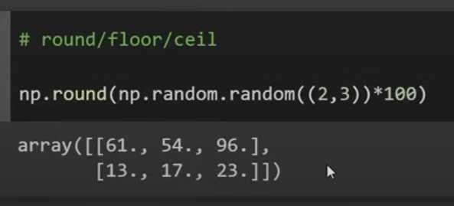

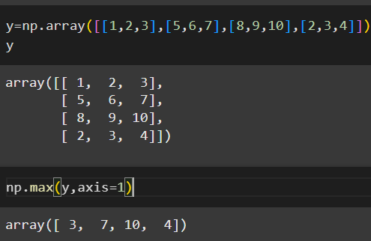

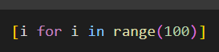

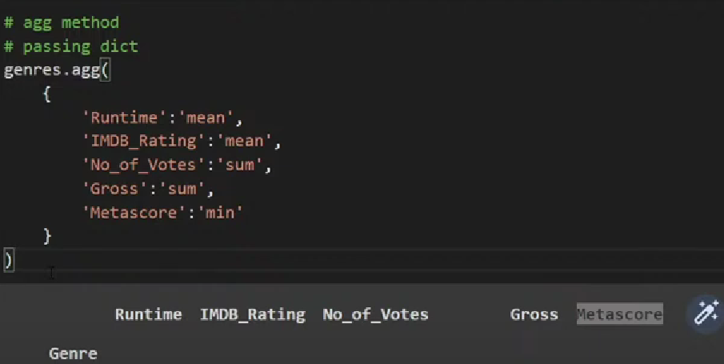

Groupby: Based on the column we form group 🡪 Groupby always form on the basis of categorical column.

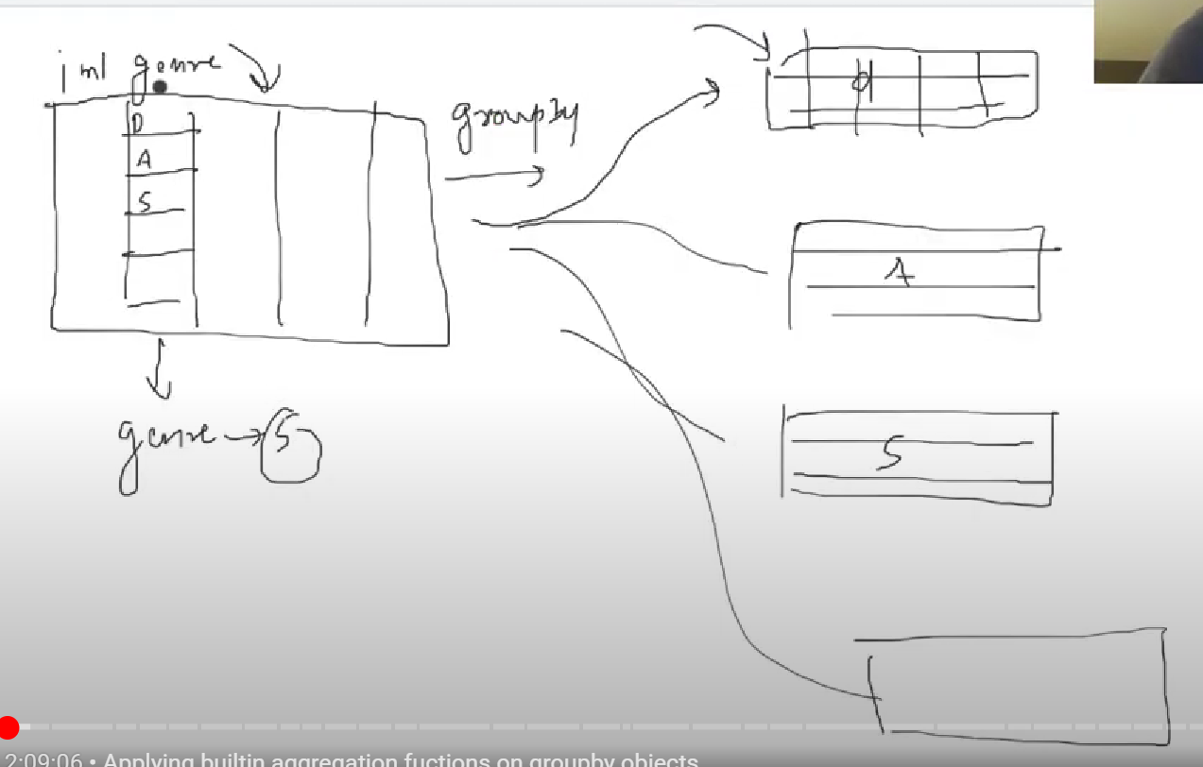

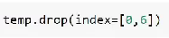 temp.drop(columns=[“name”,”iD”])

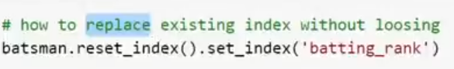

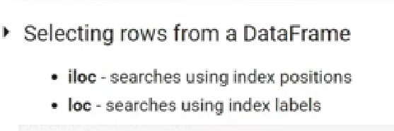

Selecting both rows and columns together 🡪

movies.iloc[rows,columns]

movies.iloc[0:3,0:3]

movies.loc[“Nitin”:”Neha”,”INTELLIGENCE”:”PACKAGE”]

Multiple rows/columns dataframe se nikaloge toh uska type dataframe hi hoga

Jb bhi ek single column/row ko fetch karoge from data frame toh who ekk series hi hoga

Multiple column fetch using fancy indexing(list) from dataframe still it remains dataframe

type(Ipl[‘Venue”]) 🡪 Series

Ipl.drop_duplicates() # **first occurrence delete**

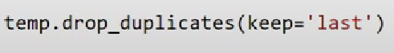 **#last occuence delete**

Ipl.duplicated()

Ipl.isnull().sum()

Ipl.size() 🡪 it counts all the values including missing

Ipl.count() 🡪 only count non missing values

Ipl.dropna()

Ipl.dropna(how=”all”) # whii rows hategi jinme saari row khali hai

Ipl.fillna()

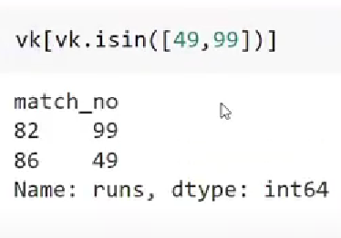









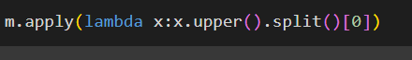

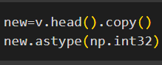 **always make a copy of head and tail because it is the original one ,if u make some changes here it will reflect back to your original data also**

Describe gives the summary of numerical columns

🡪Any structure that have rows and colums will be a dataframe for pandas

Pandas mein object hota hai string

Ipl.shape 🡪 (rows,columns)

Ipl.dtypes

Series mein .values🡪 1D array

Dataframe mein .values 🡪 2D array

2D structure of data consisting of rows and columns is called dataframe and every single column and row is called SERIES,in series we have two things index and their values

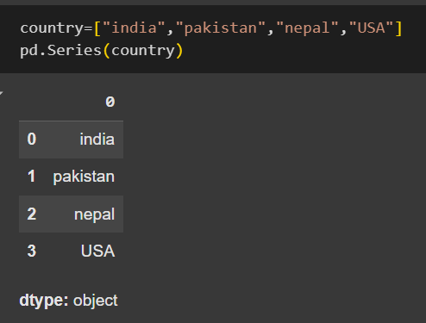

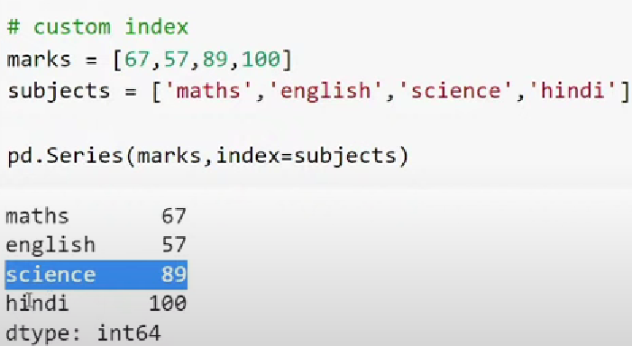

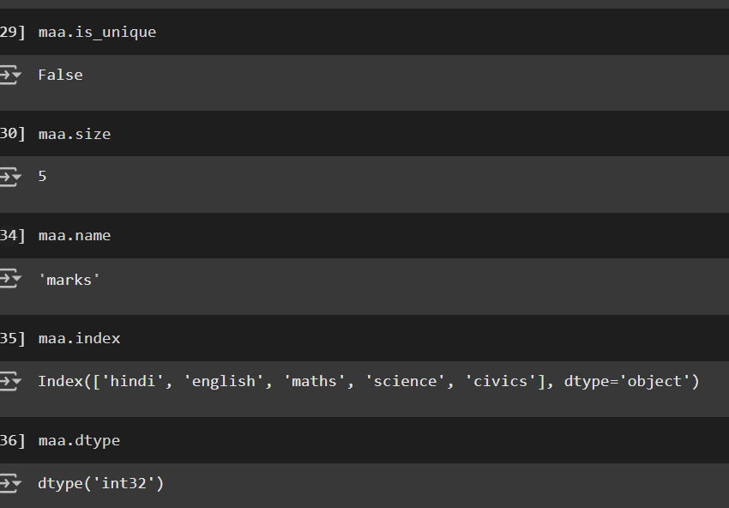

Maa.values

DATFRAME CONSIST OF MULTIPLE SERIES

Pd.Series(index=)

pd.read_csv(“”,index_col=)



vk.astype('int32')

vk[vk.between(99,100)].size # both 99 and 100 included

movies.apply(lambda x: x.split()[0].upper())

Slicing -> ek sath multiple items fetch krna

In PANDAS SERIES (ONLY POSITIVE INDEXING WORK AND NEGATIVE INDEXING WORK(WHEN THE INDEX IS STRING)

Marks={“HINDI”:67,”ENGLISH”:78,”MATHS”:77}

Marks_Series=pd.Series(Marks,name=”Marks_Nitin”) # Marks_Series is the the object of Class Series and now it can access the attributes of class Series

pd.read_csv stores data in the form of DATAFRAME(BY DEFAULT) NOT SERIES

vk.sort_values(inplace=True) #Permanent change In original

vk.sort_index(ascending=False,inplace=True) #Permanent change In original

vk.value_counts()

vk.sample()

vk.size🡪 count missing values

vk.count() 🡪 don’t count missing values

subs.sum()

vk.describe() 🡪 provides a mathematical summary

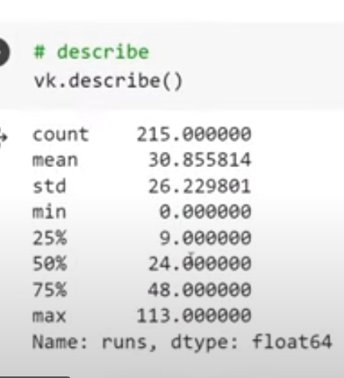

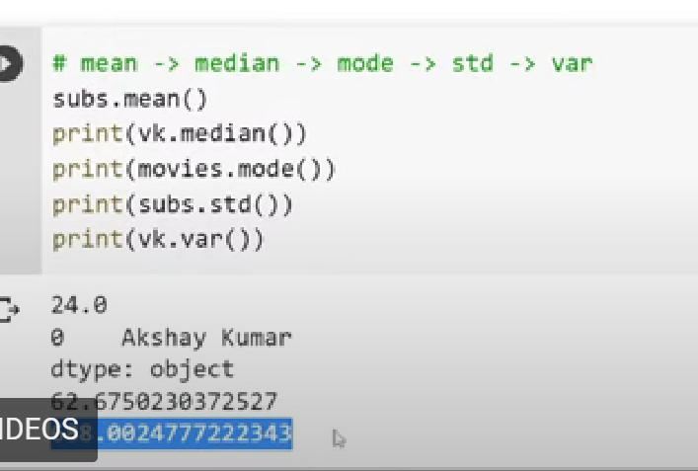

Fancy indexing also works in pandas series

Vk[[1,2,3]]

Movies[[“”]]

In a table 🡪 One column is called as Series in Pandas dtype= Object means “Strings”

Boolean Indexing :**1. Boolean Indexing**

**Boolean indexing** allows you to select elements from a NumPy array based on conditions

array([ 1, 2, 3, 4, 5, 6, 7, 8, 9, 10, 11, 12, 13, 14, 15])

(a[a>=3])

array([ 3, 4, 5, 6, 7, 8, 9, 10, 11, 12, 13, 14, 15])

Membership operator 🡪 INDEX

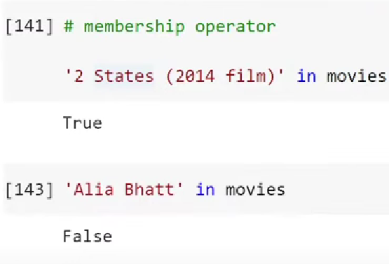

LOOPS-🡪 VALUES (FOR I IN MOVIES)

MEMBERSHIP->work on index ,if want to work on values then use

"Uri: The Surgical Strike" in movies 🡪 TRUE

“Alia bhatt” in movies.values🡪 TRUE

Fancy Indexing :**Fancy indexing** allows you to select specific elements from a NumPy array by using **integer arrays** or **lists** of indices.

**Key Characteristics of Lists:**

* **Dynamic**: Lists can grow and shrink in size as elements are added or removed.
* **Heterogeneous**: A single list can store elements of different data types.
* **Flexible**: Lists support a wide range of operations, such as indexing, slicing, appending, and more.

**Key Characteristics of Arrays:**

* **Homogeneous**: All elements must be of the same type (e.g., all integers, floats, etc.).

Broadcasting 🡪 How numpy treats arrays with different shape during arithematic operations

The smaller array is broadcast along the larger array so that they have compatible shapes

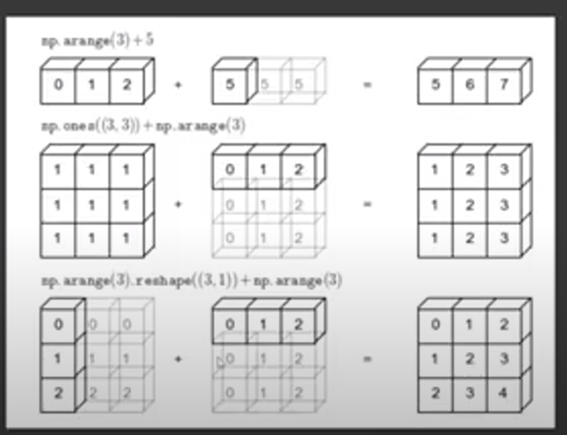

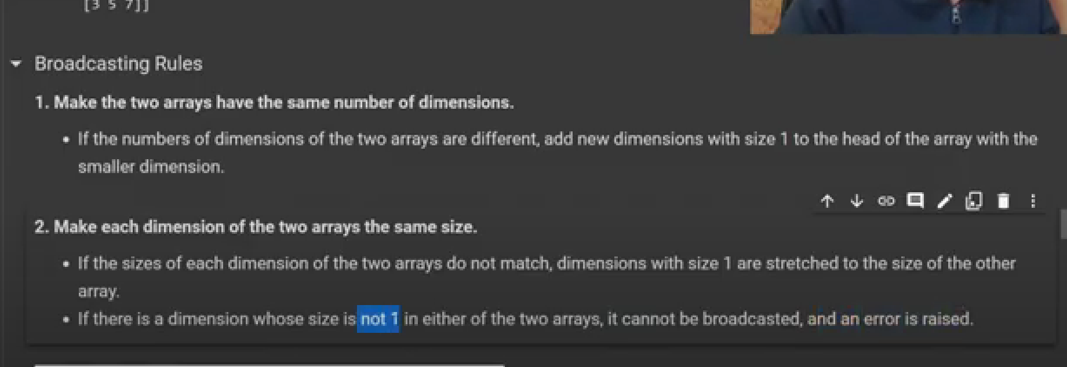

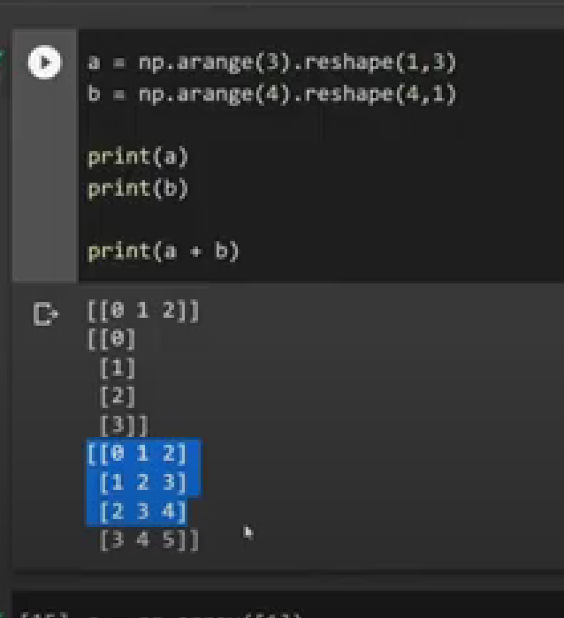

np.sort(a)[::-1] 🡪 to sort in descending orderr

np.sort(a)🡪 by default ascending order sorting

np.where(condition,True,False)

np.where(a>50) 🡪 it will return the index position of it

np.append(a,32)

np.argmax(a) 🡪 return indices of the max number in the array

np.argmin(a)

np.corrcoef(sal,experience)

pandas🡪

movies.dtypes

movies.isnull().sum()

**SORT_VALUES ON DATAFRAME🡪**

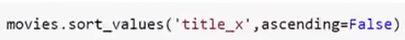

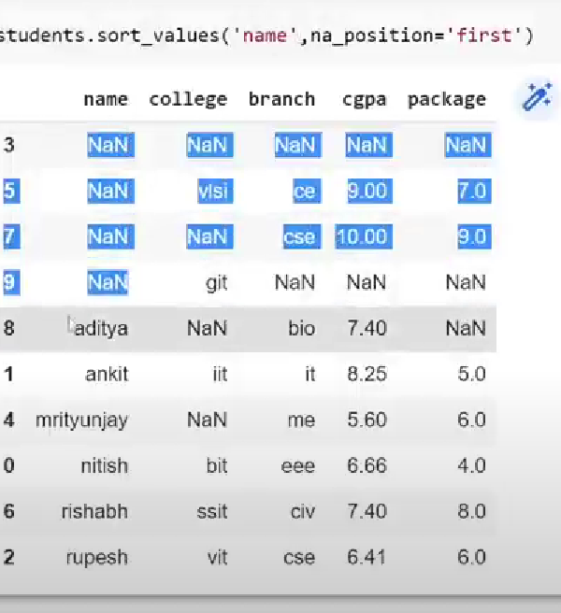



SORT VALUES ON MULTIPLE COLUMNS🡪



**TO CHANGE THE COLUMN NAME 🡪 IN A DICTIONARY**



**TO FETCH SINGLE COLUMN🡪**

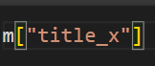

**TO FETCH MULTIPLE COLUMN** 🡪 WE PASS IT IN LIST

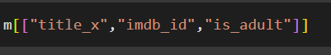

TO FETCH SINGLE ROW🡪

m.iloc[0]

TO FETCH MULTIPLE ROWS🡪

m.iloc[0:5]

#fancy indexing

m.iloc[[1,2,5,7]] iloc 🡪 index position always available



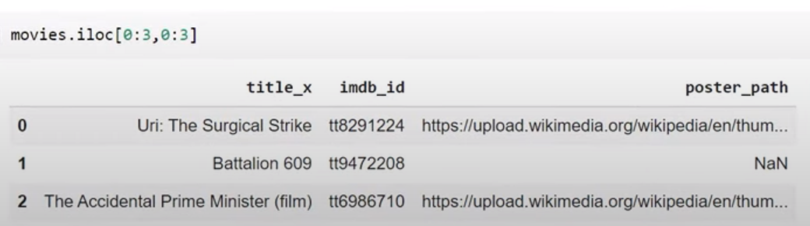

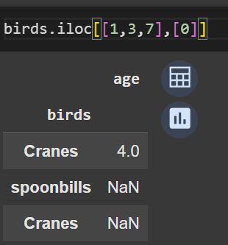

🡪Value_counts() in dataframe puri row ko count krta hai

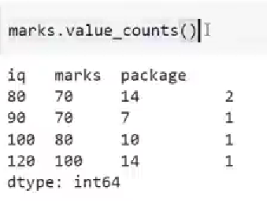

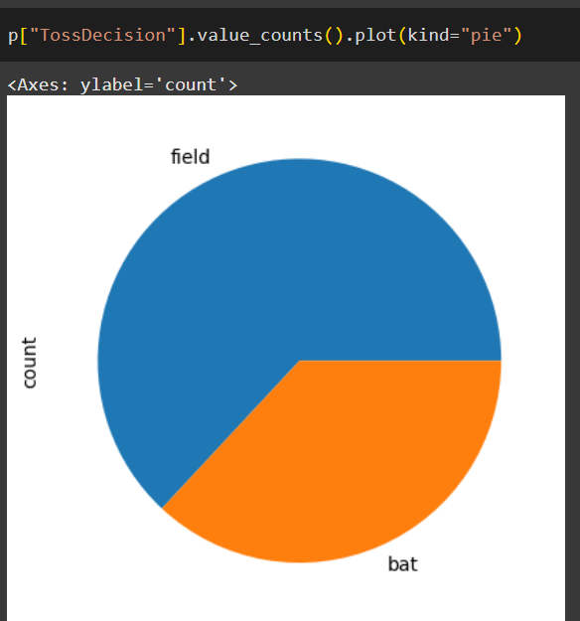

**Series ke upr aap Plot function call krke bta skte ho konsa sa chart bna hai**

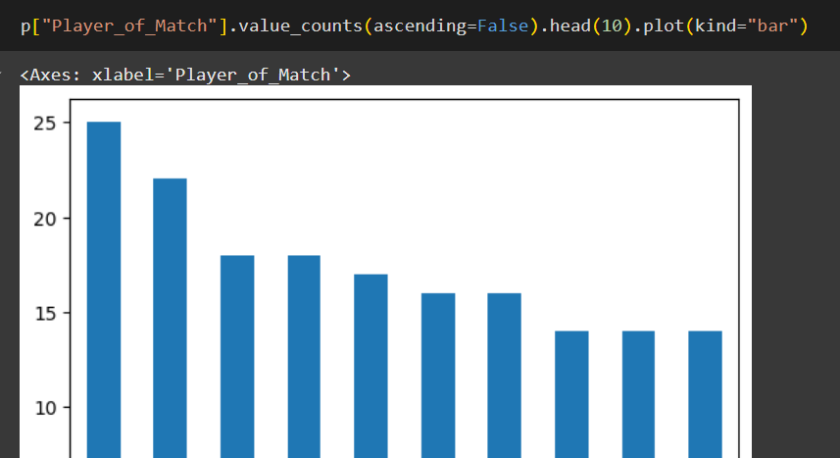

**RANK FUNCTION🡪 WORKS ON SERIES**

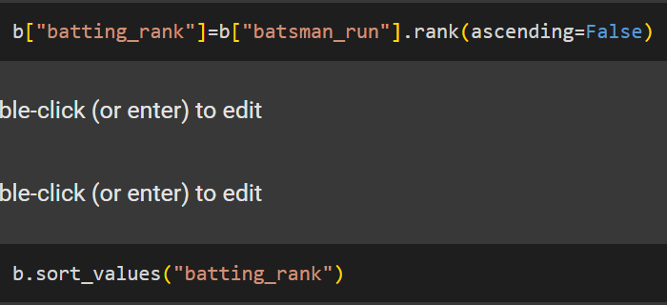

**Set_index 🡪 Used in dataframe**

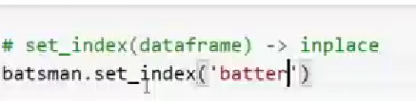

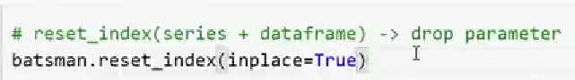

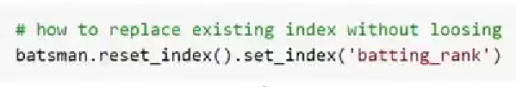

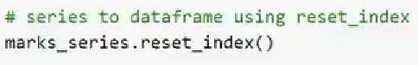

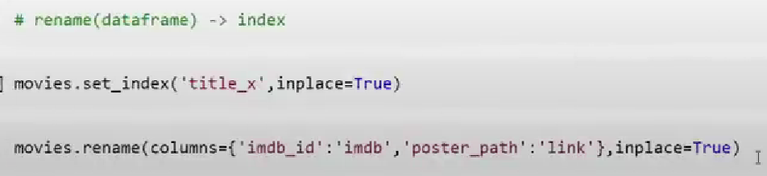



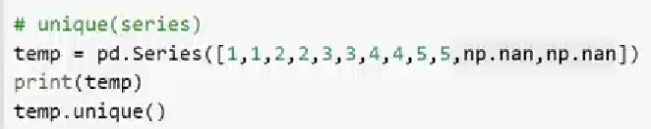

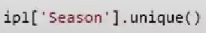

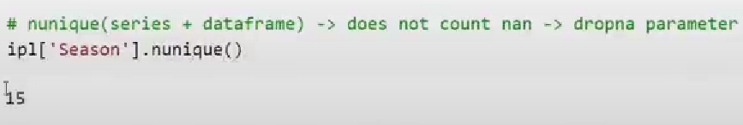

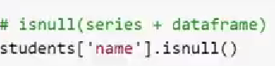



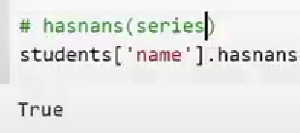

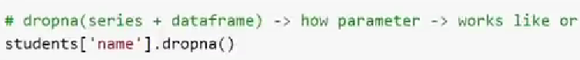

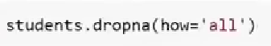

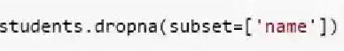



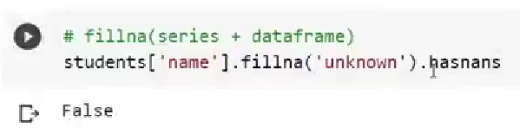





**method=”ffill”**

**method=”bbill’’**

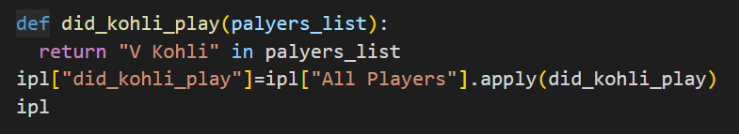





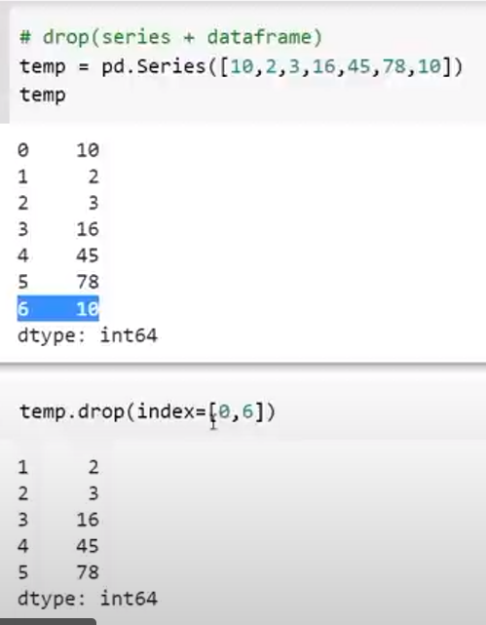

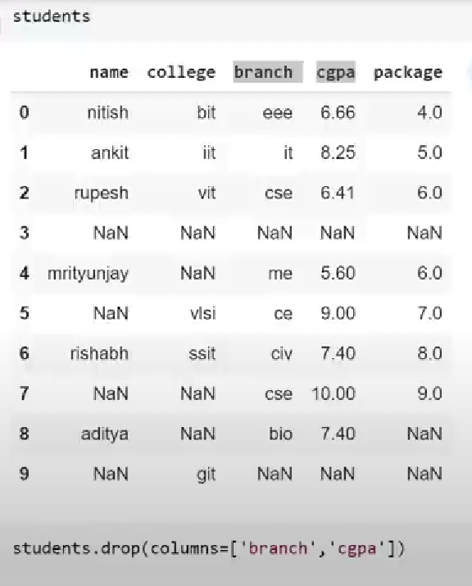

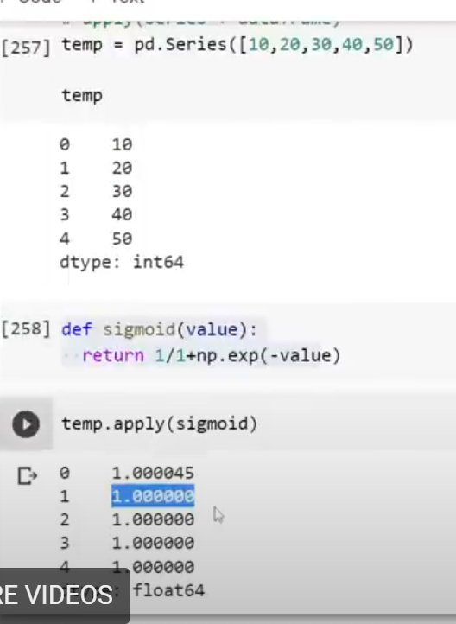

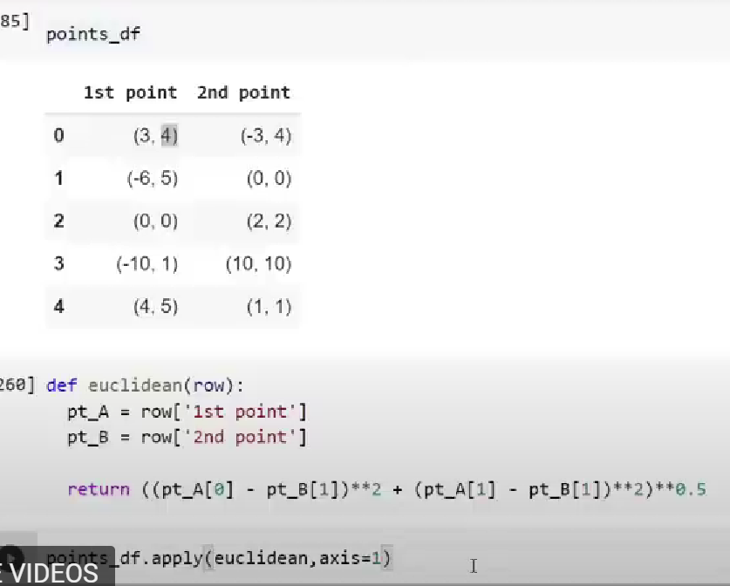

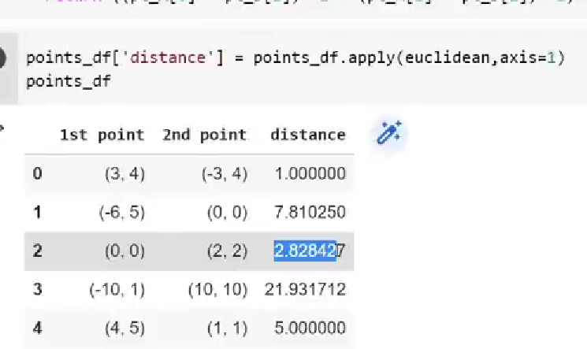

**genre=movies.groupby(“Genre”)**

**genre.sum(numeric_only=True)**

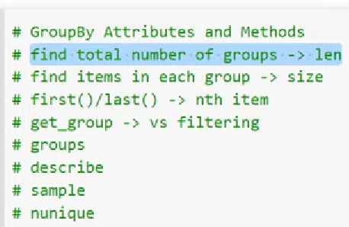

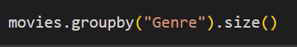

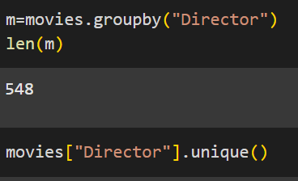



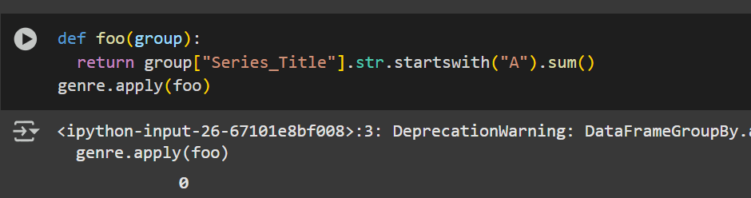

**Group by on multiple cols just pass the list**

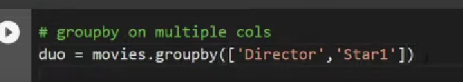

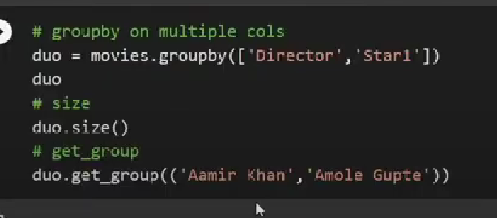

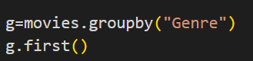

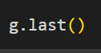

**For every group 7th movie**

**g.nth(6)**



**movies[movies[“Star1”]==”Aamir Khan”]**

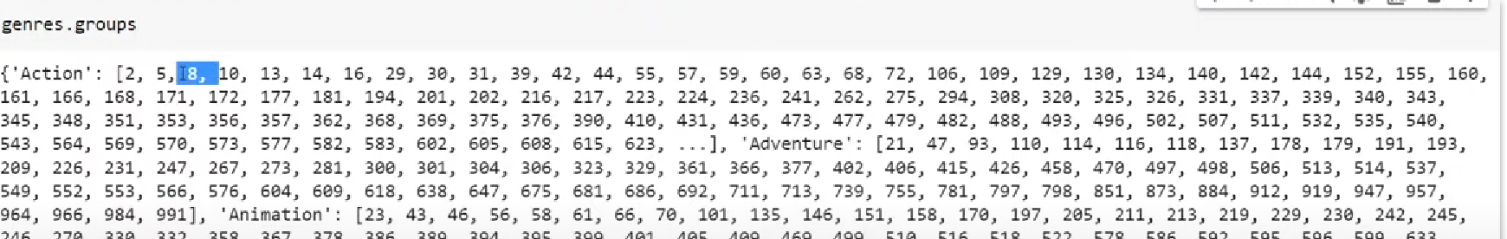

**genres.describe()  
**

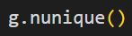

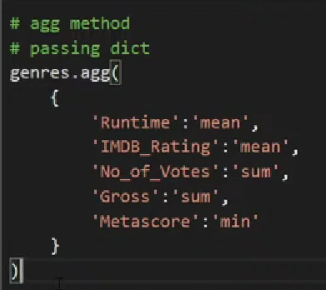

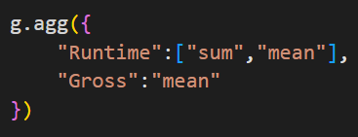

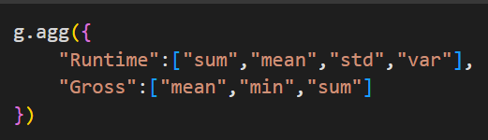

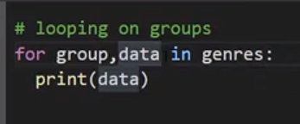

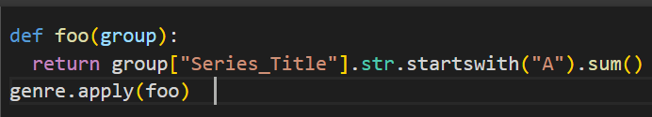

**Apply🡪 (splitting🡪logic🡪combine)**

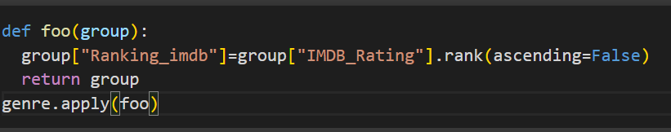

**Rank function applies on Series only**



**Single column graph plot🡪 Univariate**

**Two column graph plot🡪 Bivariate**

**More than two column graph-> multivariate**

**2D LINE PLOT🡪 Bivariate Analysis**

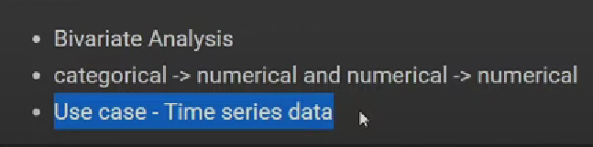

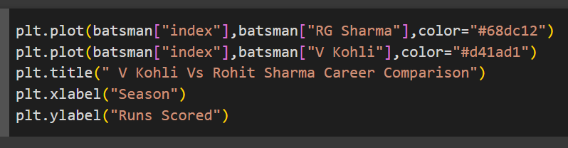

**Hidden parameter🡪 color->hex code**

**🡪Linestyle=(dashed,solid,dotted,dashdot)**

**🡪linewidth=3**

* + **marker=”D”,”*”,”+”,”>”,”O”**
  + **markersize=5**
  + **label=”Rohit”**
  + **label=”Virat”**

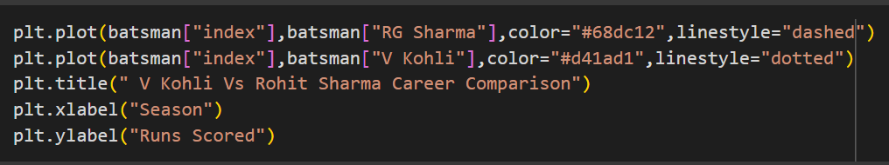

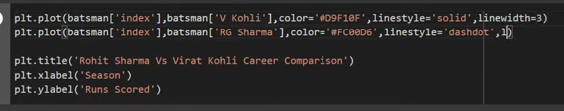

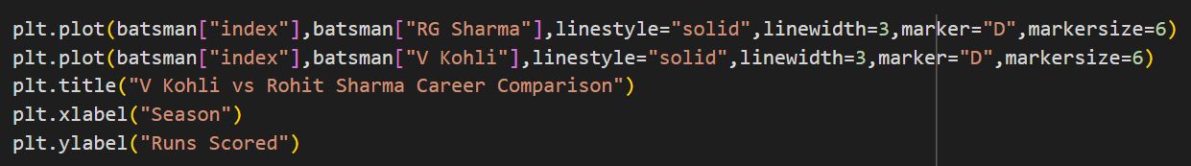

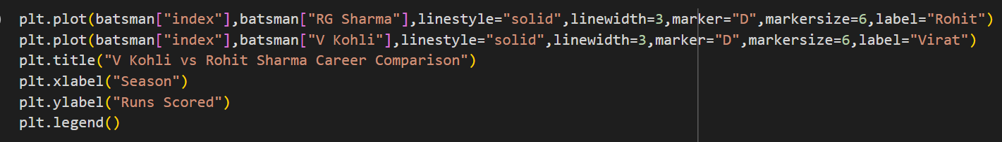

**When there is a outlier in your data 🡪 use trim**

**plt.xlim**

**plt.ylim**

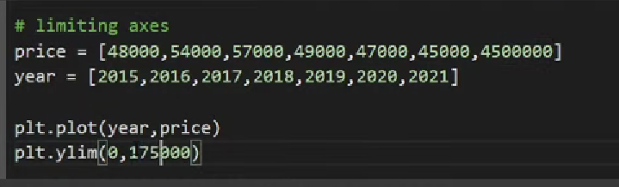

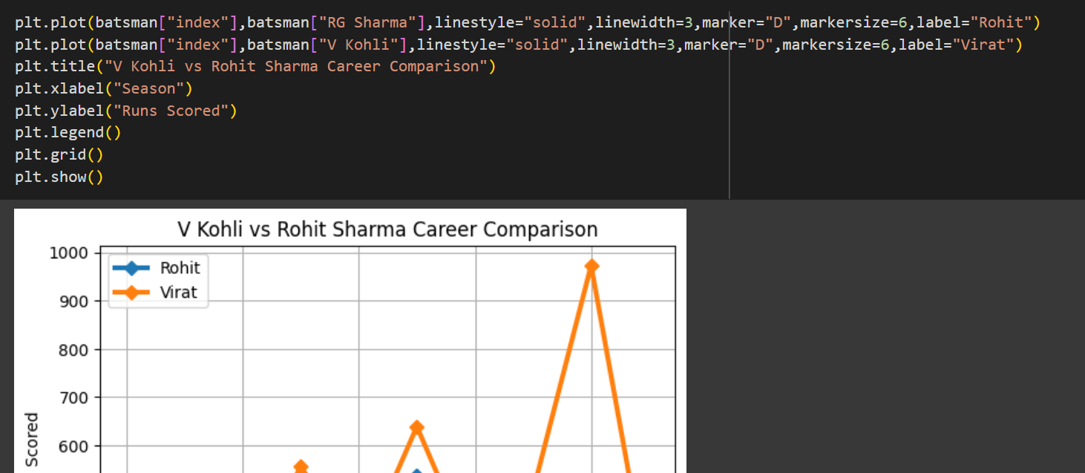

**Two ways to plot scatter plot🡪**

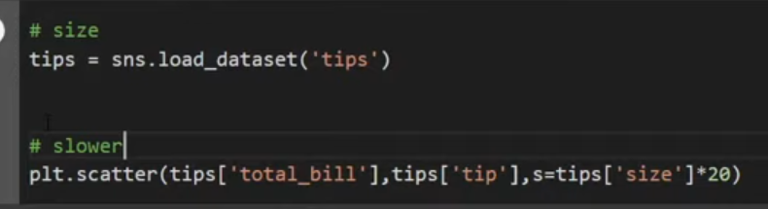

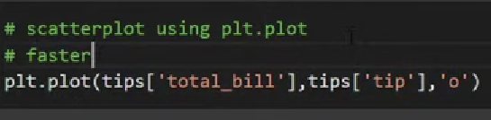

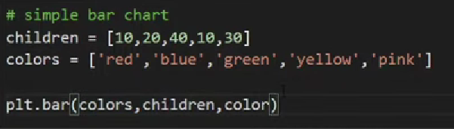

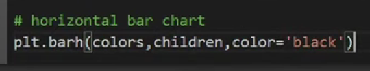

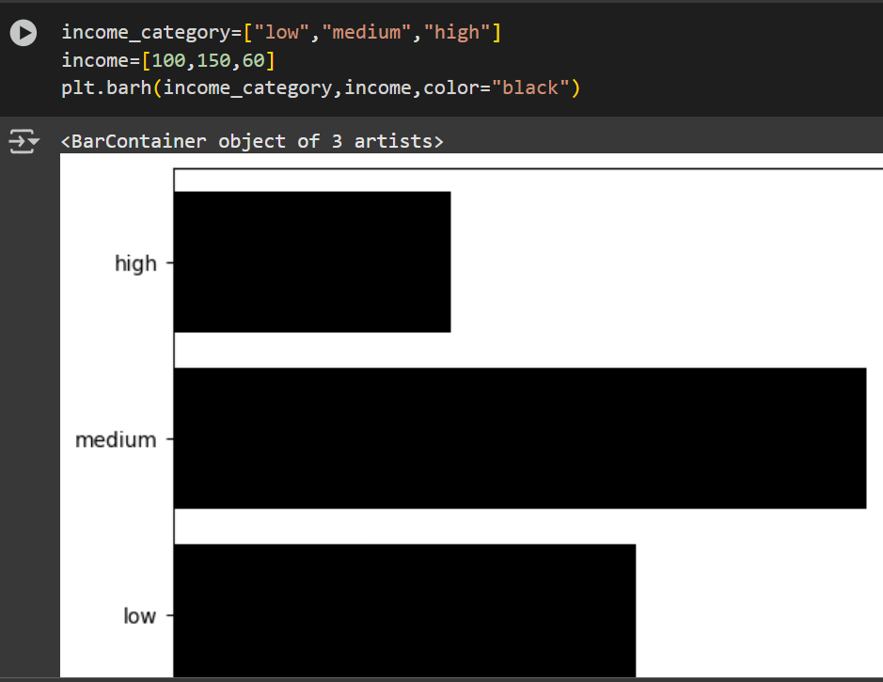

**If there are too many categories in the x axis with very big names it might get overlap with each othert so to avoid that we use plt.xticks(rotation=”vertical”)**

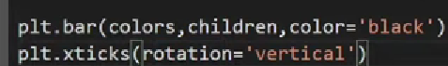

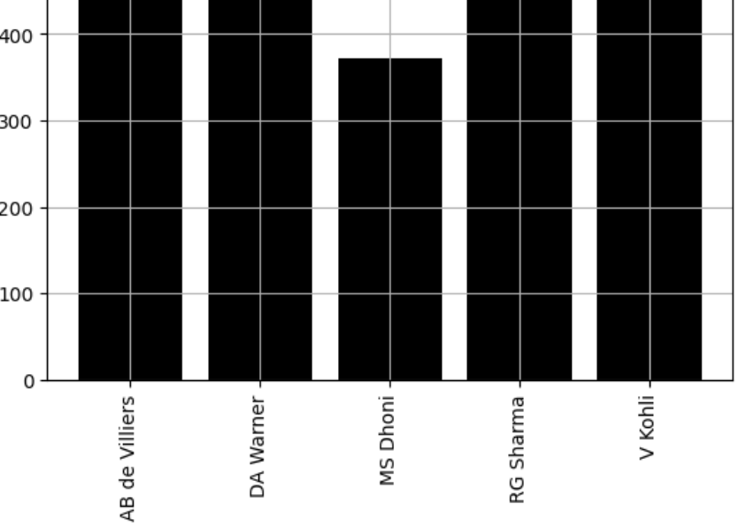

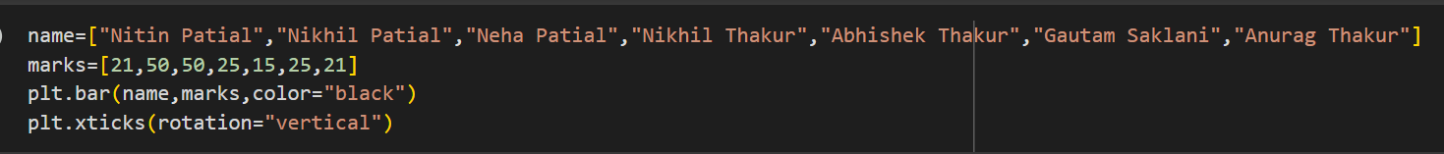



**Pie chart🡪 To find the contribution on standard scale**

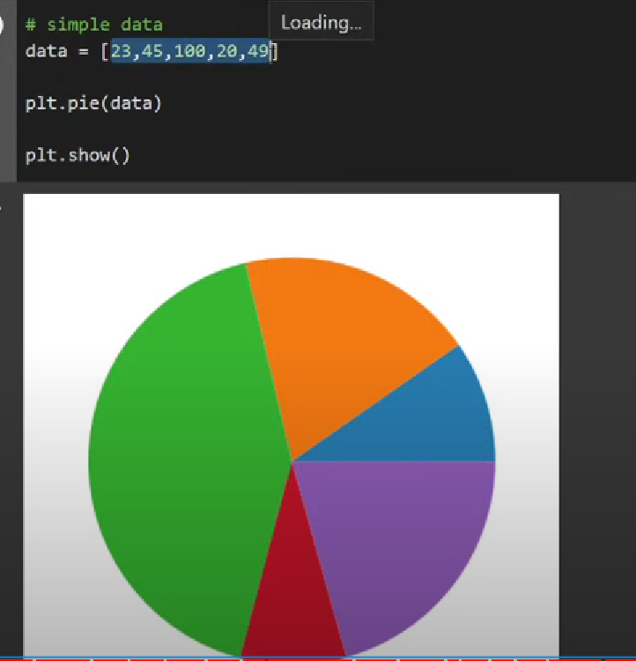

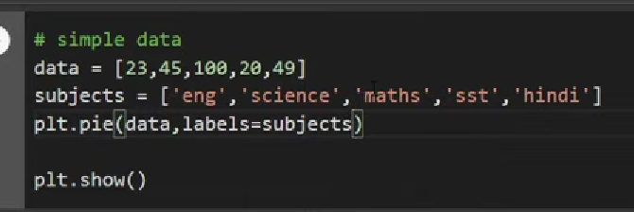

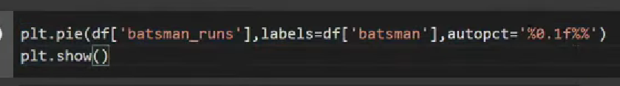

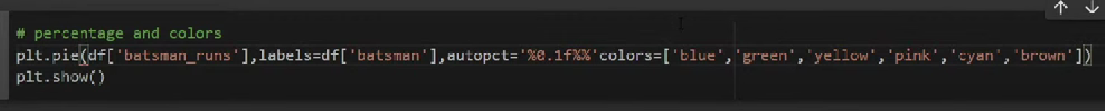

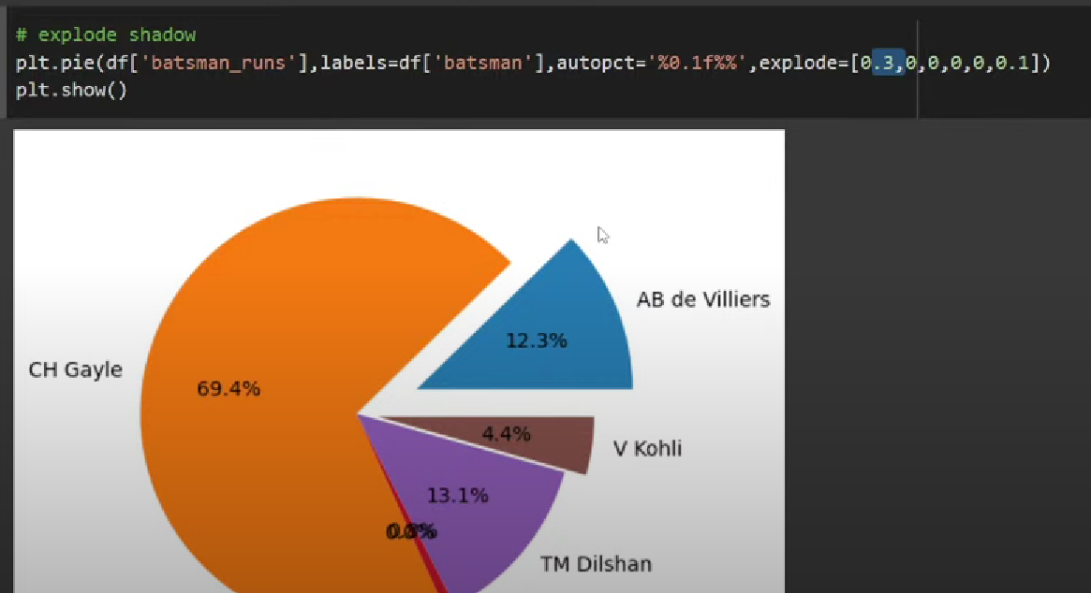

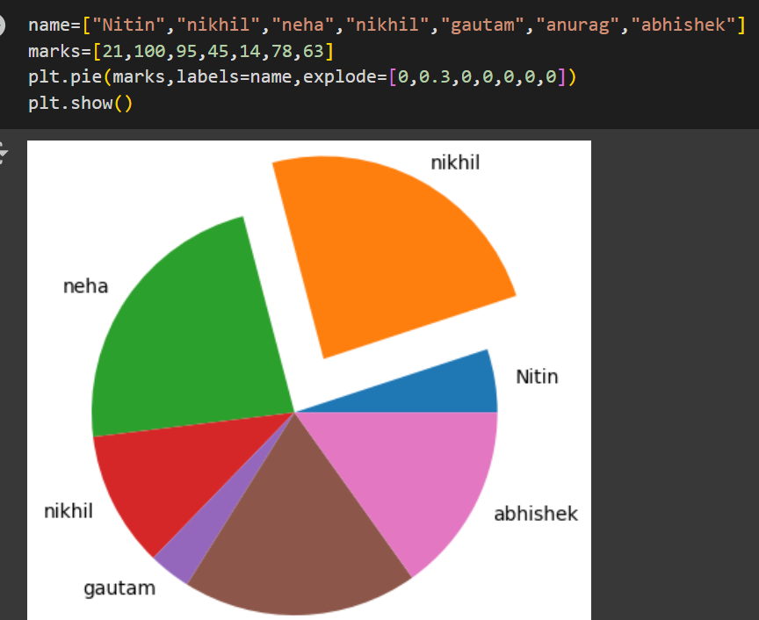

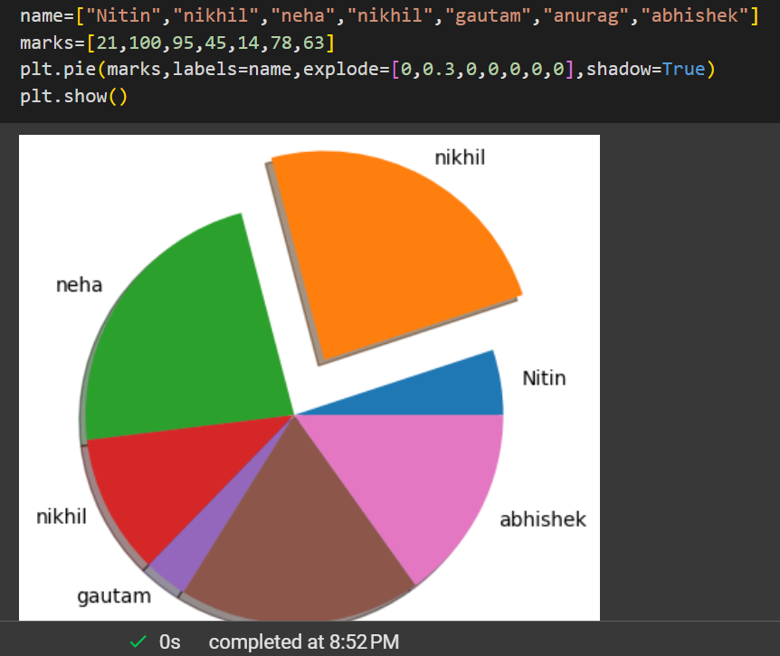

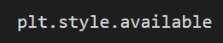

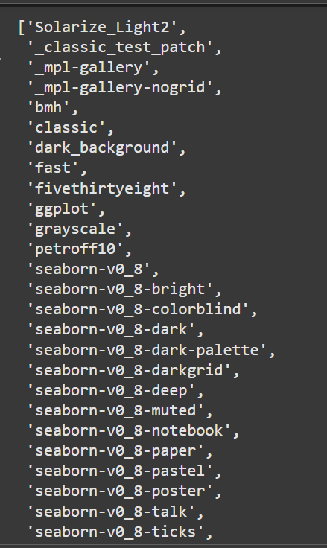

**plt.style.use(“ “)**

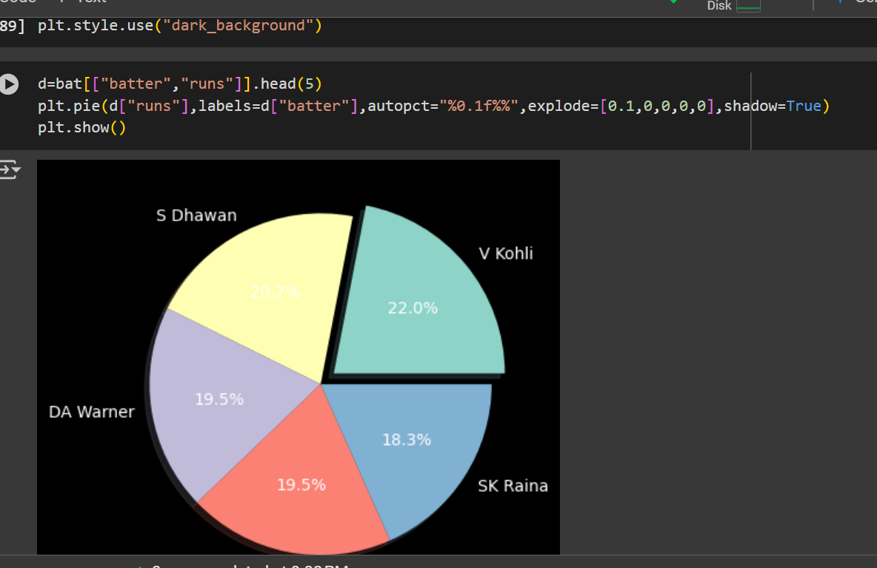

**# to save the graph**

** save it without plt.show()**

**If u go to matplotlib u will se different graphs and visuals and there tutorials too**



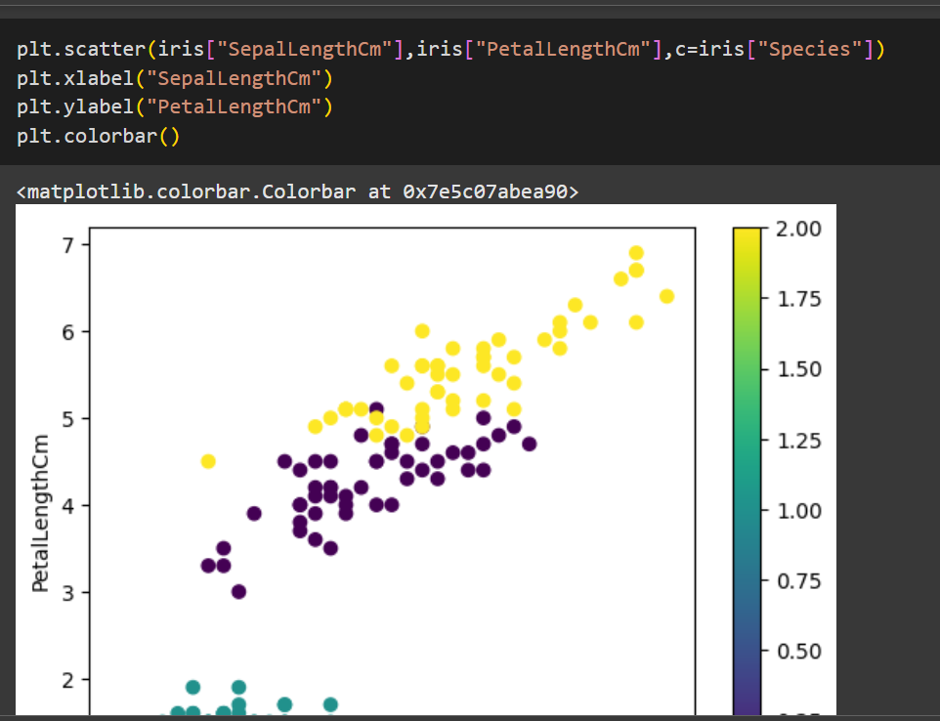

**Visual appeal 🡪 alpha🡪0 to 1**

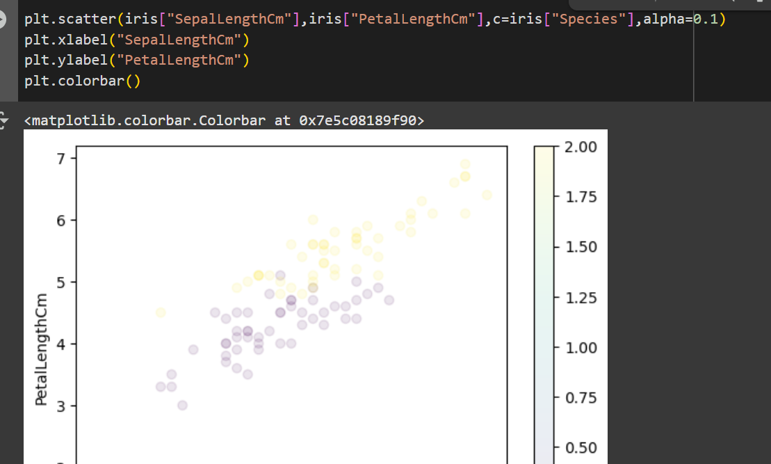

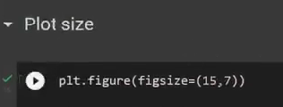

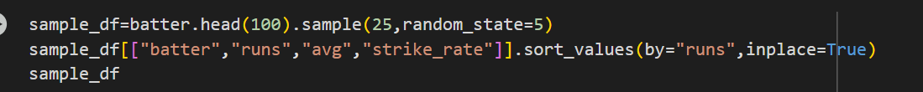

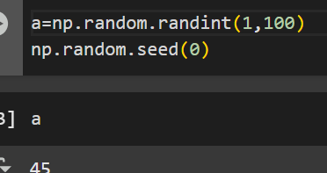

**Labelling the points🡪**

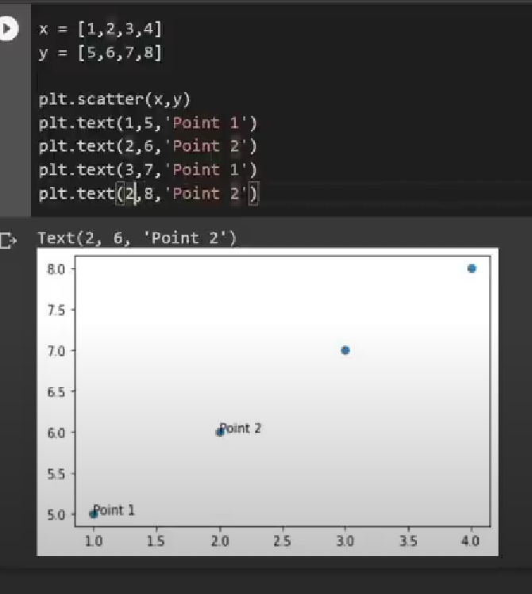

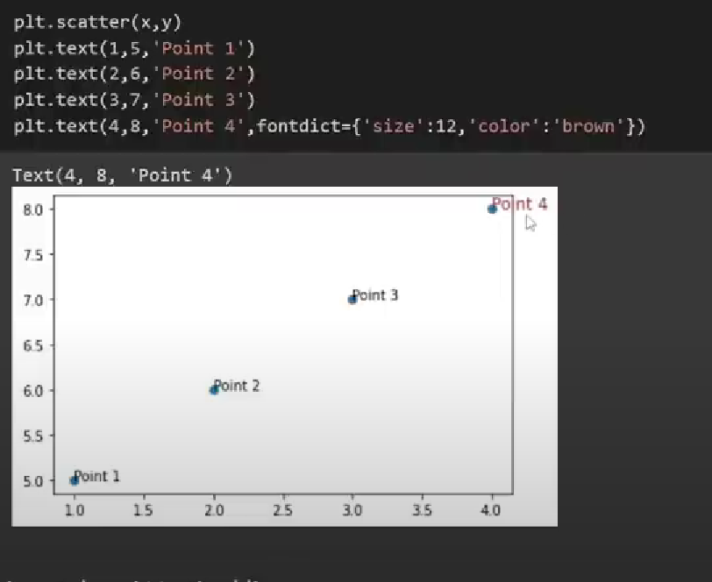

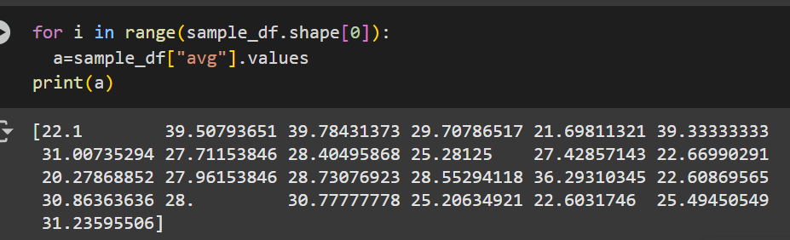

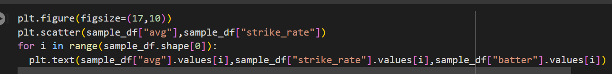

**If u want to increase the size of bubble based on the runs**

**s=sample_df[“runs”]**

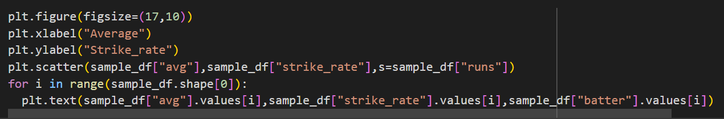

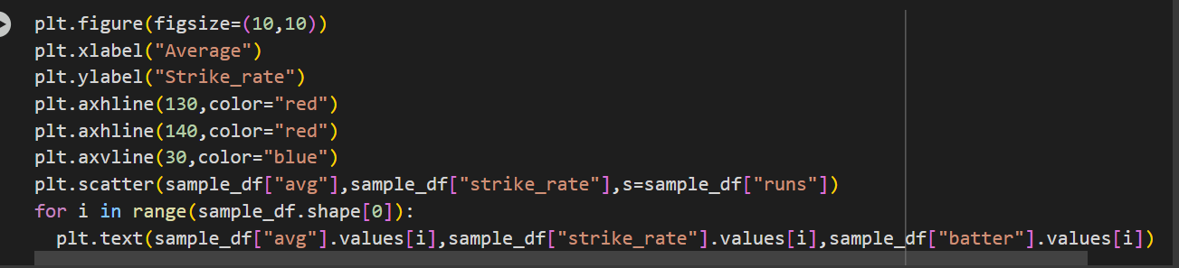

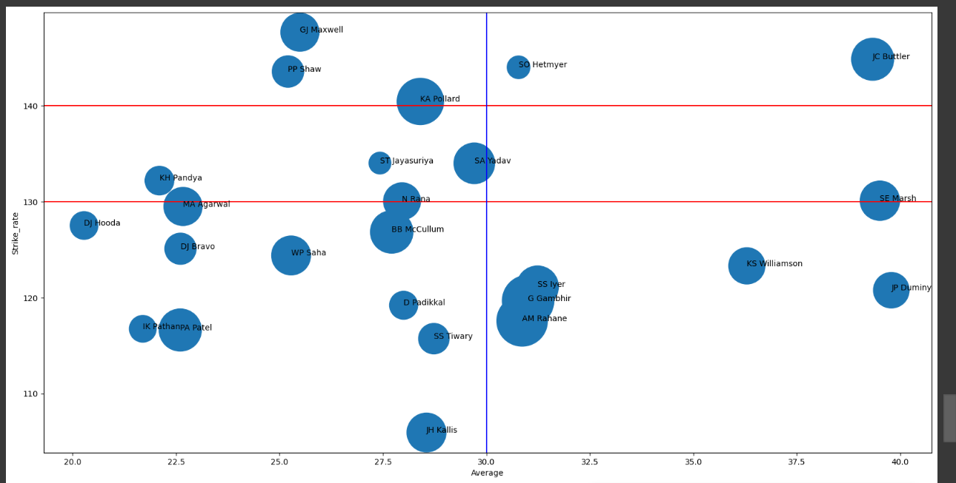

**Another way to plot graphs using**

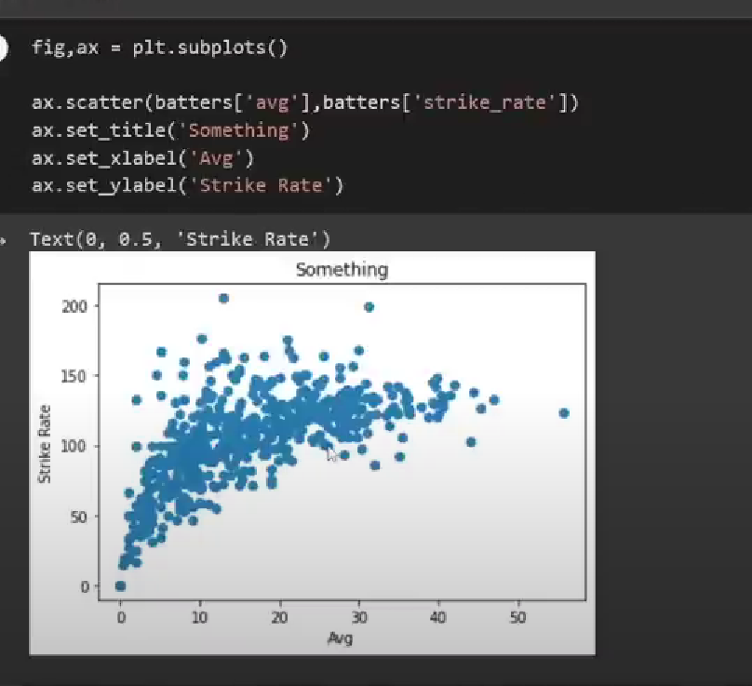

**plt.subplot give u two thing one is axes and another is figure**

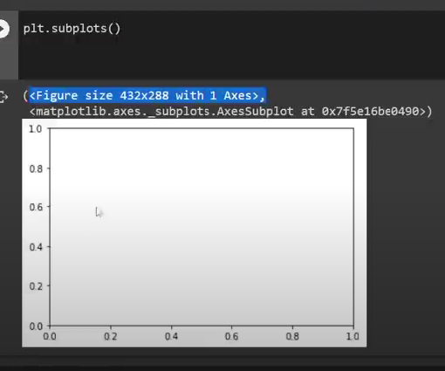

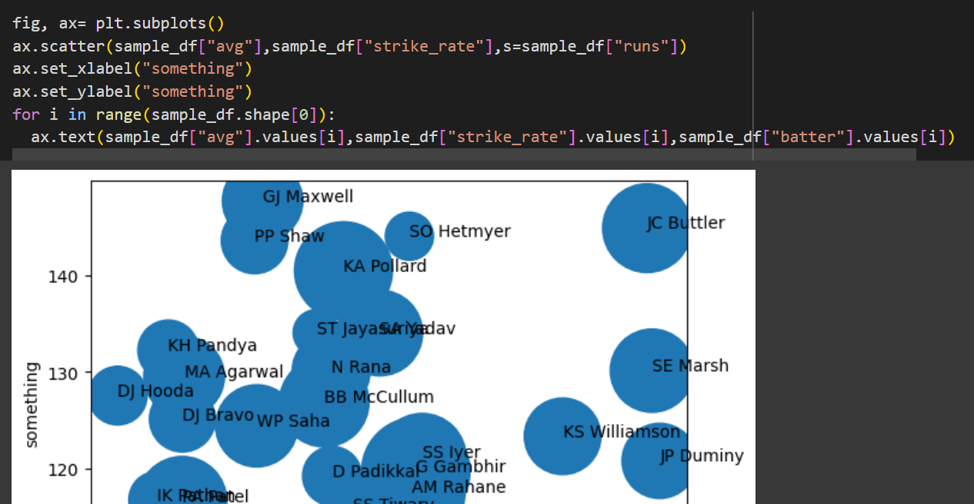

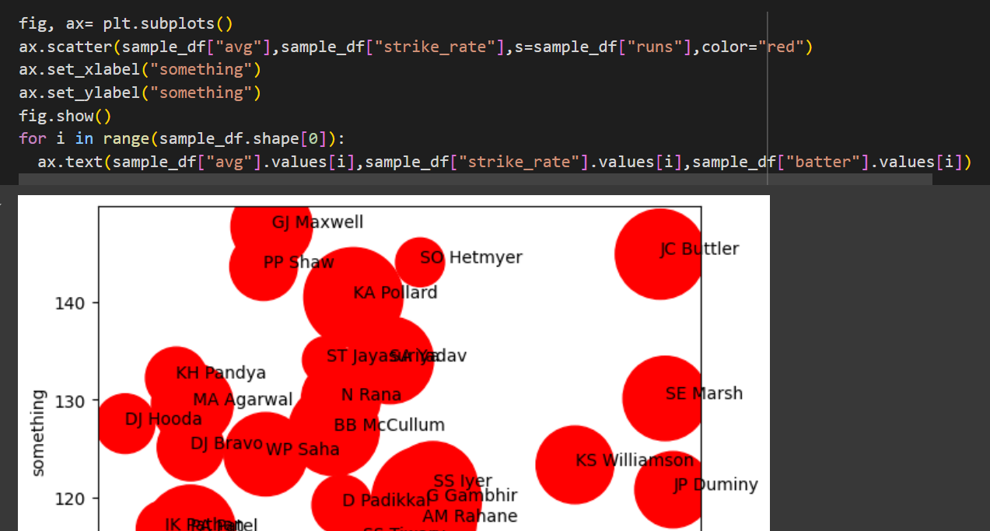

**If u want to plot multiple graphs in one figure then use this**

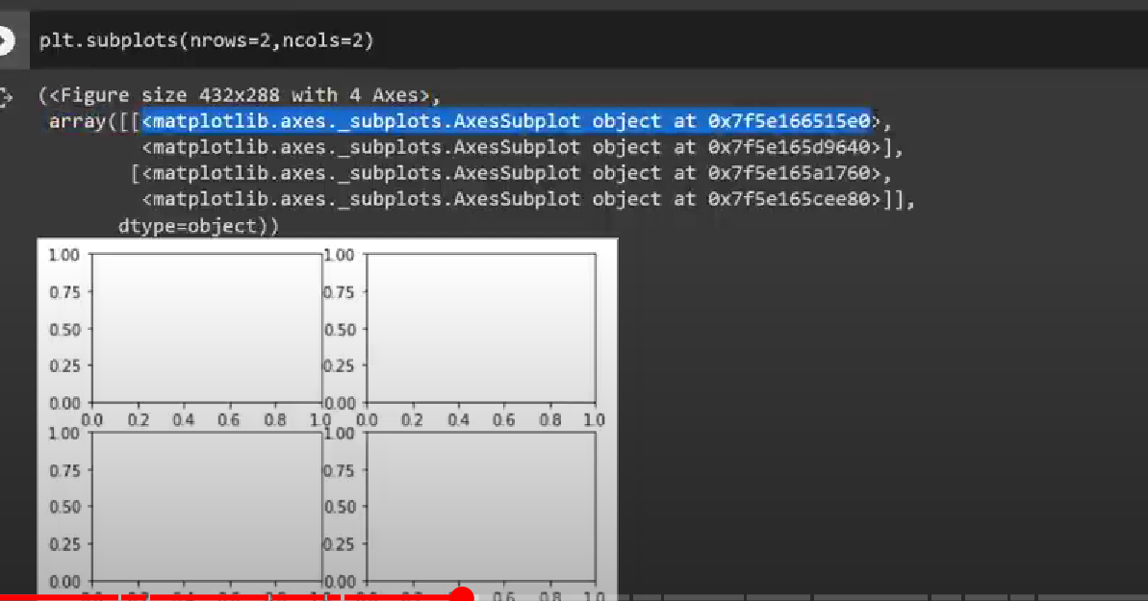

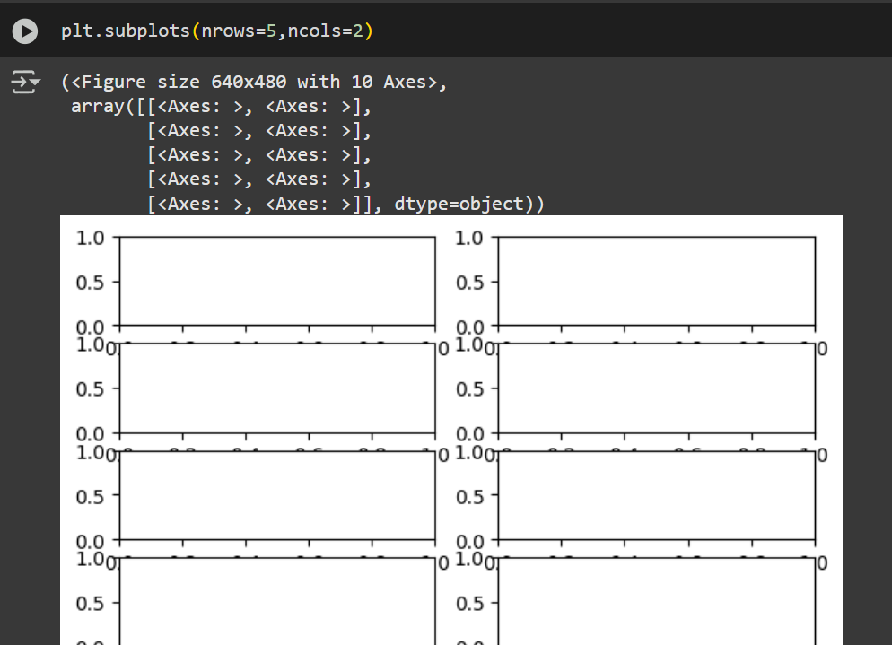

**fig,ax will store figure and array**

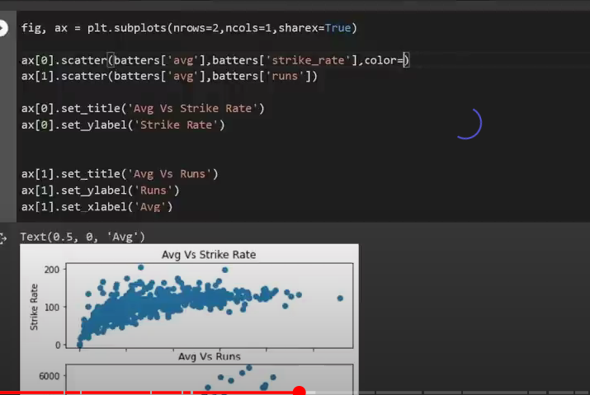

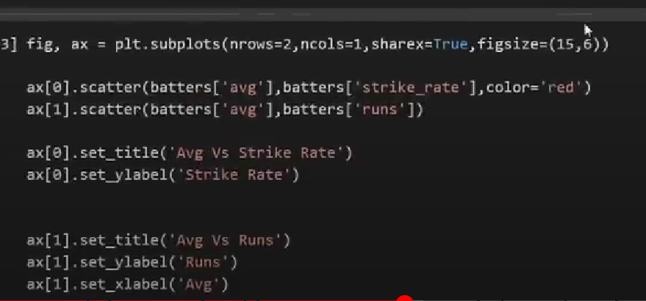

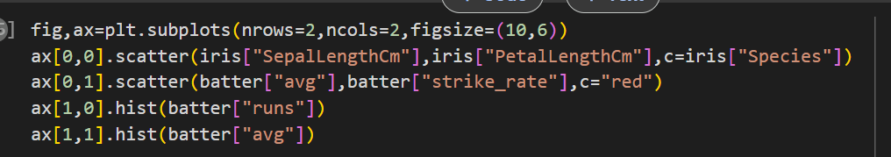

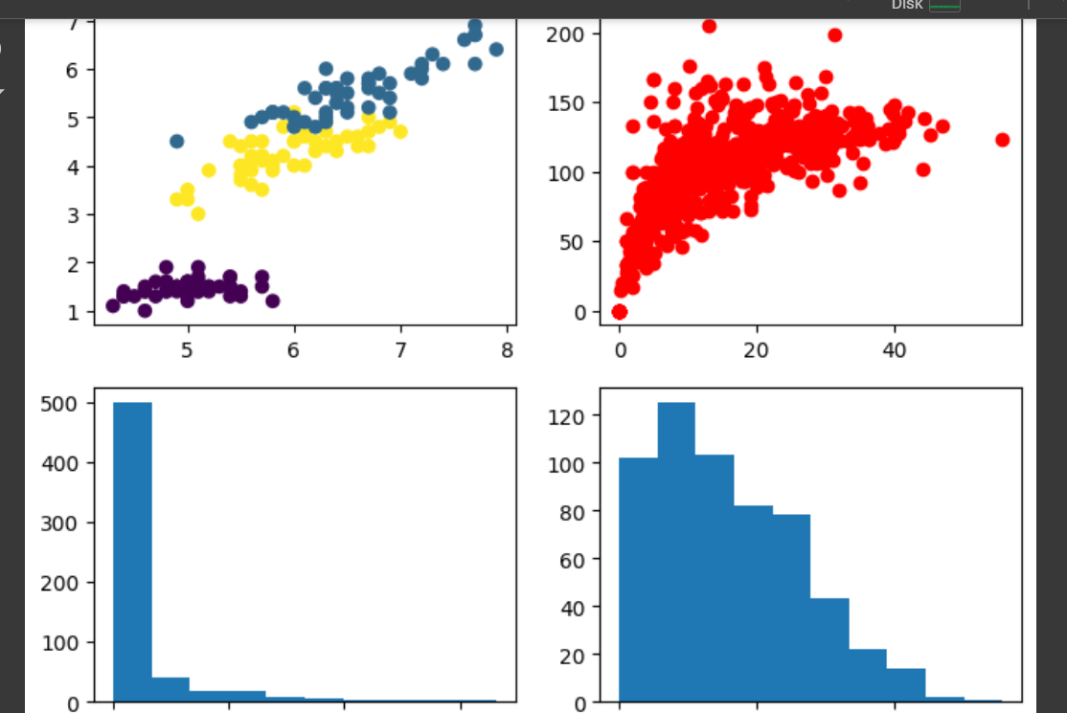

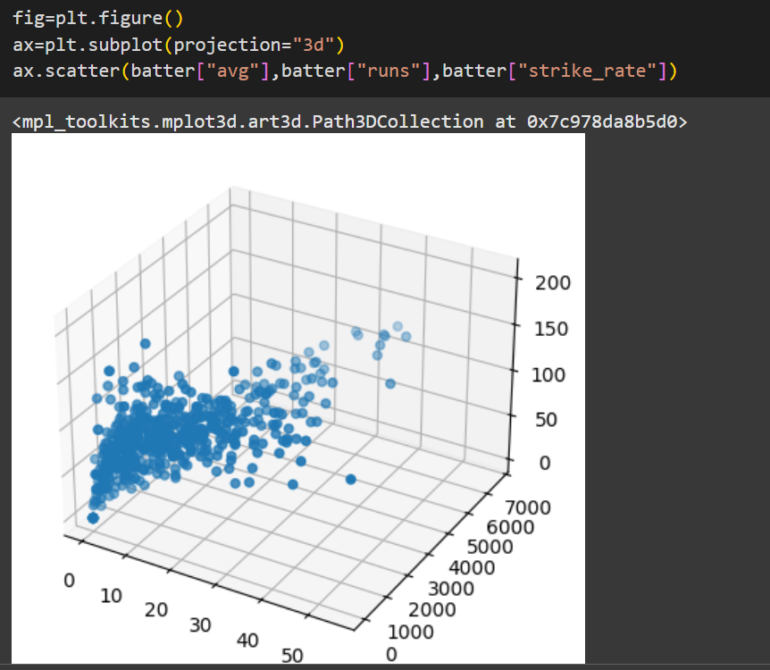

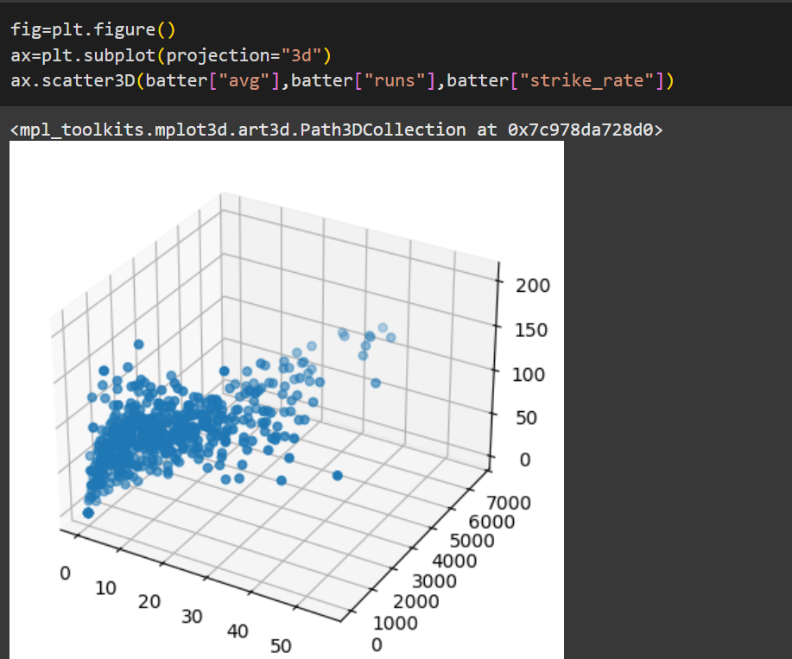

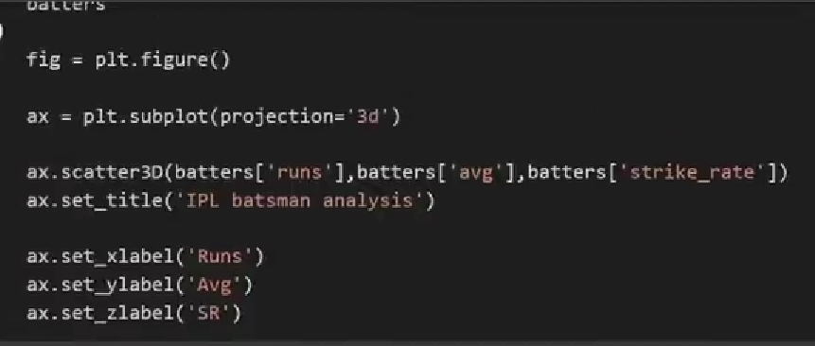

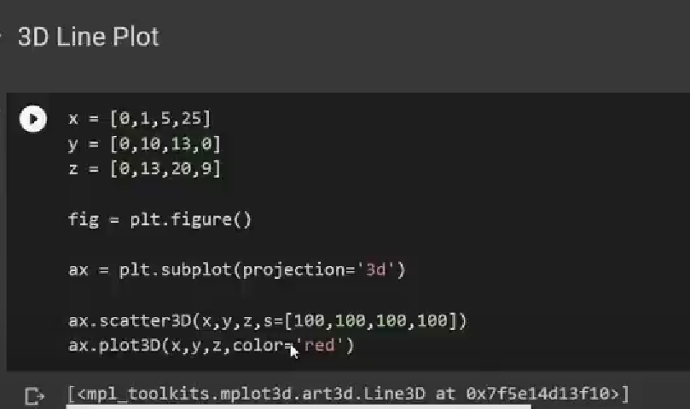

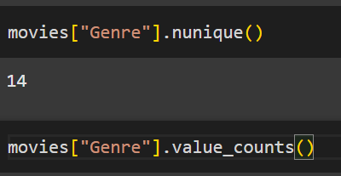

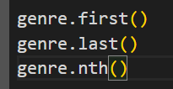

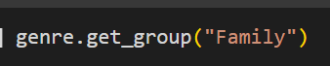

**genre.group # will give u the index position of each group**

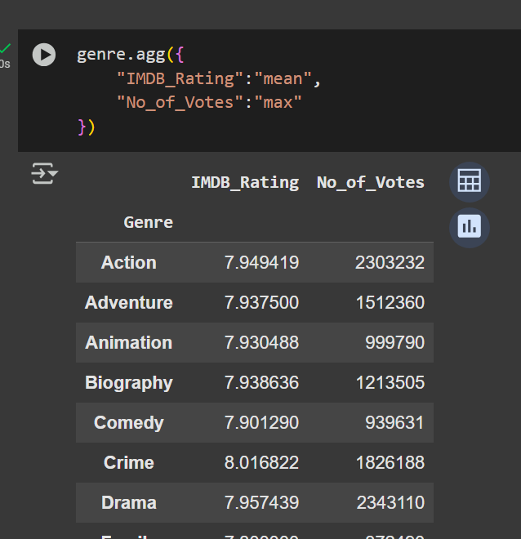

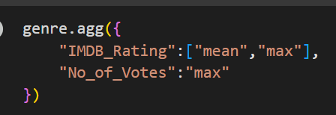

**To combine two dataset vertically use**



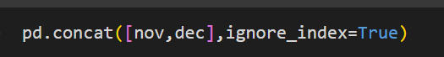

**Multiindex dataframe ,it will retain the previous index**

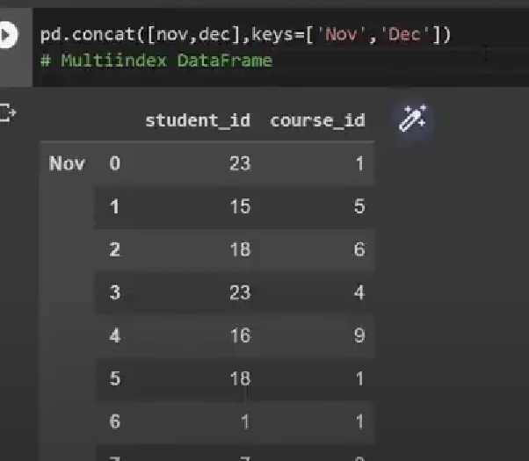

**Iloc🡪 integer based index**

**Loc🡪 label based index**

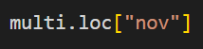

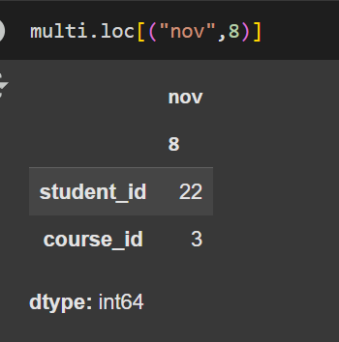

**Horizontally stack two dataframes🡪**



